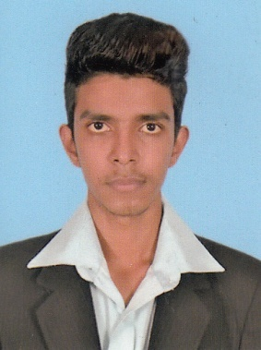

**PERSONAL QUALIFICATION**

* **Name in Full : Hussain Fariz Abdul Thariq**
* **Address : 93/15, Jinthupitiya Aandival St., Colombo 13.**
* **Date of Birth : 23rd of December**
* **Age : 19 Years**
* **N.I.C. No : 963583192V**
* **Nationality : Sri Lankan**
* **Gender : Male**
* **Civil Status : Single**
* **Religion : Islam**
* **Contact No : 0773912073 / 0774844590**
* **School Attended : Oasis International School**
* **Email Address : mtariaq@gmail.com**

**Educational Qualifications**

* **I have faced G.C.E. Ordinary Level Examination**

**Subject Grade**

**English B**

**ICT C**

**Commerce C**

**Science S**

**Islam S**

**Other Qualifications**

* **Doing Diploma in ICT Course (Information Communication Technology) Played in School Football Match.**

**Conclusion**

**I certify that the information given in these curriculum vitae is true and correct.**